

**FINAL YEAR PROJECT REPORT BS (Computer Science)**

**FARM ANIMAL BREED**

**DETECTION**

**SUBMITTED BY**

|  |  |
| --- | --- |
| **SYED KAIF ALI** | **51239** |
| **SHAH ABDUL MUNIM** | **51276** |
| **HAMID GHULAM HAMZA** | **51230** |
|  |  |

**FACULTY OF ENGINEERING, SCIENCE AND TECHNOLOGY IQRA UNIVERSITY, KARACHI**

**MARCH 2024**



**FACULTY OF ENGINEERING, SCIENCE AND TECHNOLOGY**

**DEPARTMENT OF COMPUTER SCIENCE**

**FINAL YEAR PROJECT REPORT BACHELOR OF COMPUTER SCIENCE**

**SYED KAIF ALI (51239)**

**SHAH ABDUL MUNIM (51276)**

**HAMID GHULAM HAMZA (51230)**

**PROJECT:**

**FARM ANIMAL BREED DETECTION**

**MARCH 2024**

**ABSTRACT**

In modern agriculture, the precise identification and management of farm animals play a crucial role in optimizing productivity and ensuring animal welfare. This project introduces a comprehensive solution for farm animal breed detection, specifically targeting cows and goats, through a user-friendly mobile application. The system leverages state-of-the-art deep learning techniques to analyze images captured by the user, providing real-time information on the breed, gender, and estimated weight of the animal.

The methodology encompasses a robust pipeline consisting of image preprocessing, feature extraction, and classification using a convolutional neural network (CNN) architecture trained on a diverse dataset of cow and goat breeds. Gender recognition is achieved through an innovative fusion of visual attributes and characteristic anatomical features, while weight estimation relies on predictive models utilizing animal size and morphology.

The implementation of this system offers significant benefits to livestock farmers by enabling rapid and accurate identification of individual animals, facilitating targeted breeding programs, health monitoring, and nutritional management. Preliminary evaluations demonstrate promising results in breed classification and attribute recognition, showcasing the system's adaptability to varying environmental conditions and animal poses.

This project underscores the transformative potential of computer vision technologies in revolutionizing traditional farming practices, empowering farmers with valuable insights for informed decision-making and resource optimization. Future research avenues may explore scalability enhancements, integration with IoT devices for real-time data collection, and deployment in diverse agricultural settings to further enhance efficiency and sustainability in livestock management.

We have approved this manuscript for submission and presentation as fulfillment of Bachelor of Software Engineering/ Computer Science.

Supervisor:

Dr.Aarij Hussan Mahmood

Date: 23-03-2024

**DECLARATION**

I hereby declare that the work has been done by myself to fulfill the requirement of the BS (Software Engineering) and no portion of the work contained in this report has been submitted in support of any application for any other degree or qualification of this or any other university or institute of learning.

I hereby further declare that in the event of any infringement of the provision of the Act whether knowingly or unknowingly the university shall not be liable for the same in any manner whatsoever and undertake to indemnify and keep the university indemnified against all such claims and actions.

© SYED KAIF ALI [51239]

© SHAH ABDUL MUNIM [51276]

©HAMID GHULAM HAMZA [51230]

**ACKNOWLEDGEMENT**

First, we thank Almighty Allah who praise us with the ability to think, work and deliver what we are assigned to do. We also acknowledge our teachers that throughout our studies helps us and guides us, departmental staff, university staff or other then this. We are also thankful to the FYP instructor **“Dr. Aarij Mahmood”** for his precious support throughout the tenure as he is the best instructor for FYP who makes every student to be updated with the project progress and lead to the completion with great success within the time period given. We are also grateful to our family and friends, for supporting and encouraging us to complete this project. Finally, we would like to thank all the colleagues of IQRA University who have been with us in all difficult times with suggestions and supportive words which carry us to make this project a reality.

# **CHAPTER NO:1**

## **INTRODUCTION:**

Livestock farming plays a pivotal role in global food security, providing essential protein sources and livelihoods for millions of people worldwide. With the growing demand for animal products and the increasing complexity of modern agricultural systems, efficient management of farm animals has become paramount. One of the fundamental challenges in livestock farming is the accurate identification and characterization of individual animals, which is crucial for effective breeding programs, health monitoring, and overall management practices.

Traditional methods of animal identification often rely on manual observation or cumbersome tagging systems, which can be labor-intensive, error-prone, and inadequate for large-scale operations. However, recent advancements in computer vision technologies offer promising solutions to streamline this process, enabling automated and non-invasive identification of farm animals based on visual cues extracted from images or videos.

In this context, this project endeavors to address the need for accurate and efficient farm animal breed detection, focusing specifically on cows and goats. The primary objective is to develop a user-friendly mobile application that harnesses the power of deep learning techniques to analyze images captured by farmers or field workers, providing valuable insights into the breed, gender, and approximate weight of the animals.

By leveraging convolutional neural networks (CNNs), a cutting-edge approach in image recognition, the proposed system aims to overcome the challenges associated with traditional methods of animal identification. Through a carefully curated dataset comprising diverse breeds of cows and goats, the CNN model will be trained to recognize distinct visual patterns and features associated with each breed, enabling robust classification performance.

Moreover, the incorporation of gender recognition and weight estimation functionalities enhances the utility of the system, empowering farmers with comprehensive information for informed decision-making and resource management. By seamlessly integrating advanced computer vision capabilities into everyday farming practices, this project seeks to enhance efficiency, productivity, and sustainability in livestock management.

The following sections will provide an in-depth overview of the methodology, implementation, and evaluation of the proposed farm animal breed detection system, highlighting its potential impact on agricultural practices and future research directions.

## **PROBLEM STATEMENT:**

Traditional methods of identifying and characterizing farm animals like cows and goats are manual, error-prone, and time-consuming, hindering effective breeding programs and livestock management. Existing solutions lack comprehensive insights into key attributes such as breed, gender, and weight, limiting informed decision-making by farmers. With modern agricultural systems demanding efficient and scalable solutions, there's an urgent need for a user-friendly, automated system leveraging computer vision to accurately detect farm animal breeds, empowering farmers with real-time insights for better management and sustainability.

## **MOTIVATION:**

The motivation behind this project stems from the pressing need to modernize and optimize livestock management practices in the agricultural sector. Traditional methods of farm animal identification are outdated, labor-intensive, and often inaccurate, leading to inefficiencies and suboptimal outcomes in breeding programs, health monitoring, and resource allocation. By harnessing the power of computer vision technologies, we aim to revolutionize livestock management by providing farmers with an advanced and user-friendly solution for automated breed detection.

Furthermore, with the global population projected to reach nearly 10 billion by 2050, the demand for animal products continues to rise. It is imperative to enhance productivity and sustainability in livestock farming to meet this growing demand while minimizing environmental impact and ensuring animal welfare. Our project seeks to address these challenges by empowering farmers with real-time insights into their livestock, enabling them to make informed decisions and optimize management practices.

Moreover, the potential impact of this project extends beyond individual farms to the broader agricultural industry. By streamlining and automating farm animal identification, we aim to contribute to the advancement of precision agriculture and data-driven decision-making, ultimately driving efficiency, productivity, and sustainability in livestock farming. Additionally, the scalability of our solution makes it adaptable to diverse farming environments and accessible to farmers of all scales, from smallholders to commercial operations.

In summary, our motivation lies in leveraging cutting-edge technologies to address longstanding challenges in livestock management, empower farmers with actionable insights, and contribute to a more sustainable and efficient agricultural future.

## **OBJECTIVE:**

The objective of this project is to develop a user-friendly mobile application that utilizes computer vision techniques to automate farm animal breed detection, specifically targeting cows and goats. The key objectives include:

1. Implementing a robust image processing pipeline to preprocess input images captured by users in real-world farm environments.
2. Training and optimizing a convolutional neural network (CNN) model to accurately classify farm animal breeds, incorporating diverse datasets of cows and goats.
3. Integrating gender recognition algorithms to identify the gender of detected animals, enhancing the application's functionality.
4. Developing weight estimation algorithms based on animal size and morphology, providing additional valuable insights for livestock management.
5. Designing an intuitive and accessible user interface for the mobile application, ensuring usability and ease of use for farmers and field workers.
6. Conducting comprehensive testing and validation to assess the accuracy, reliability, and performance of the application under various environmental conditions and animal poses.

By achieving these objectives, the project aims to provide farmers with a practical tool for automated farm animal breed detection, empowering them with valuable insights for informed decision-making and optimized livestock management practices.

**RESEARCH OBJECTIVE:**

The research objective is to develop a mobile application utilizing computer vision to accurately identify farm animal breeds, genders, and estimate weights, thereby facilitating informed decision-making and improved management practices in livestock farming.

**ACADEMIC OBJECTIVE:**

The academic objective is to advance understanding and application of computer vision techniques in livestock management by developing a robust mobile application for automated farm animal breed identification, gender recognition, and weight estimation.

**MANAGEMENT OBJECTIVE**

The management objective is to enhance efficiency and productivity in livestock farming operations through the implementation of a user-friendly mobile application, enabling farmers to make informed decisions regarding breeding programs, health monitoring, and resource allocation.

## **CHALLENGES:**

Developing a mobile application for automated farm animal breed identification, gender recognition, and weight estimation requires overcoming various challenges. These challenges include acquiring diverse datasets, addressing breed variability, and ensuring accurate gender recognition and weight estimation algorithms. Additionally, real-world deployment and integration with existing farm management systems pose logistical and technical hurdles.

* Acquiring diverse and representative datasets for training the model.
* Addressing significant variability in physical characteristics within and across animal breeds.
* Ensuring accurate gender recognition and weight estimation algorithms.
* Overcoming challenges related to real-world deployment, including variable environmental conditions.
* Scaling the solution for large-scale operations while maintaining accuracy.
* Integrating the application seamlessly into existing farm management systems.

## **STRUCTURE OF REPORT:**

**Introduction:**

* Provide an overview of your project, including its objectives, significance, and the problem it aims to address.
* Introduce the key components of your project, such as farm animal breed detection, gender recognition, and weight estimation.
* Clearly state the structure of your report and what each section will cover.

**Literature Review:**

* Review existing literature on farm animal identification methods and computer vision techniques in livestock management.
* Discuss previous studies and research relevant to automated breed detection and related areas.
* Highlight the current state-of-the-art and any gaps in the literature that your project seeks to address.

**Methodology:**

* Detail the approach and methods used in your project, including data collection, preprocessing, model architecture, and training.
* Describe the algorithms developed for gender recognition and weight estimation.
* Provide an overview of the mobile application development process.

**Diagrams:**

* Include diagrams or flowcharts illustrating the workflow of your methodology, system architecture, and data processing pipelines.
* Diagrams can help readers visualize the technical aspects of your project and understand the interactions between different components.

**Use Cases:**

* Present practical scenarios or use cases where your project can be applied in real-world agricultural settings.
* Describe how farmers or field workers can utilize the mobile application for breed detection, gender recognition, and weight estimation.

**Test Cases:**

* Outline the test scenarios and methodologies used to evaluate the performance of your system.
* Provide details of the datasets used for testing, metrics for evaluation, and the results obtained.

**Screenshots of Project:**

* Include screenshots or images demonstrating the user interface and functionality of your mobile application.
* Show examples of input images, output predictions, and any visualizations generated by the system.

**Conclusion:**

* Summarize the key findings and contributions of your project.
* Reflect on the achievements, limitations, and challenges encountered during the development and testing phases.
* Discuss the potential implications of your project for agriculture and livestock management.

# **CHAPTER NO:2**

## **TECHNOLOGY BACKGROUND:**

In the realm of agricultural innovation, the fusion of cutting-edge technologies has opened new avenues for improving livestock management practices. Our project embodies this ethos by harnessing the power of Flutter and Roboflow to develop a mobile application for automated farm animal breed detection. This introduction provides an overview of the technological framework underpinning our application, highlighting the synergy between Flutter's cross-platform development capabilities and Roboflow's robust image annotation tools. Through this innovative integration, we aim to revolutionize the way farmers and livestock managers identify and manage farm animals, facilitating informed decision-making and enhancing efficiency in agricultural operations.

## **BACKGROUND OF THE TECHNOLOGY:**

In the development of our farm animal breed detection application, we leveraged the versatile capabilities of Flutter for cross-platform mobile app development, coupled with the efficient annotation process facilitated by Roboflow. This technology stack offers a powerful combination of flexibility, ease of use, and scalability, enabling us to create a robust and user-friendly solution for automated breed identification in livestock farming.

**Flutter for Mobile App Development:**

* Flutter, developed by Google, is an open-source UI software development kit used for building natively compiled applications for mobile, web, and desktop from a single codebase.
* It offers a rich set of pre-designed widgets and customizable components, facilitating rapid development and seamless integration of features across different platforms.
* Flutter's hot reload feature allows developers to instantly see changes made to the code, speeding up the iterative development process and enhancing productivity.

**Roboflow For Data Annotation:**

* Roboflow is a cloud-based platform that simplifies the process of annotating and managing image datasets for machine learning projects.
* Through Roboflow, we were able to efficiently annotate our dataset of farm animal images with labels for breed, gender, and other relevant attributes.
* The platform offers various annotation tools, including bounding boxes and polygons, making it easy to annotate images accurately and efficiently.

## **TECHNOLOGY INTEGRATIONS:**

* We utilized Python as the primary programming language for backend development and machine learning model training.
* Python's extensive libraries and frameworks, such as TensorFlow and OpenCV, provided robust tools for image processing, model development, and integration with
* Flutter.
* The annotated dataset prepared through Roboflow was seamlessly integrated into our Python-based machine learning pipeline, enabling us to train and fine-tune convolutional neural network (CNN) models for breed identification, gender recognition, and weight estimation.

Overall, the combination of Flutter for mobile app development and Roboflow for data annotation, coupled with Python for backend processing and machine learning, empowered us to create a comprehensive and efficient solution for farm animal breed detection. This technology background underscores our commitment to leveraging cutting-edge tools and methodologies to address real-world challenges in agriculture and livestock management.

## **LITERATURE REVIEW:**

Farm animal breed detection and identification have emerged as crucial components of modern livestock management, leveraging advancements in computer vision technologies. Within agricultural research and practice, significant attention has been devoted to exploring methodologies and techniques for automating breed recognition processes. These studies underscore the importance of accurate and efficient breed identification in enhancing breeding programs, health monitoring, and overall management practices within the livestock industry.

A considerable body of research, exemplified by studies such as [1], has demonstrated the efficacy of convolutional neural networks (CNNs) in accurately classifying animal breeds based on visual features extracted from images. By training CNN models on diverse datasets of farm animal images, researchers have achieved notable success in breed classification tasks, highlighting the potential of deep learning techniques in addressing complex agricultural challenges.

Furthermore, investigations into the application of computer vision extend beyond breed identification, encompassing related tasks such as gender recognition and weight estimation in farm animals. Studies such as [2] have explored the feasibility of utilizing deep learning models for gender recognition and weight estimation, providing valuable insights into the integration of computer vision technologies into broader livestock management workflows.

In parallel, the emergence of mobile app development frameworks like Flutter has facilitated the creation of intuitive and user-friendly applications for agricultural purposes. Research by [3] showcases the versatility of Flutter in building responsive and feature-rich mobile interfaces, making it an attractive option for implementing farm animal breed detection and management functionalities.

Complementing these developments, data annotation platforms such as Roboflow offer efficient solutions for preparing annotated datasets required for training machine learning models. By streamlining the annotation process and providing robust tools for dataset management, platforms like Roboflow play a crucial role in accelerating the development of AI-driven solutions for agricultural applications.

Despite these advancements, a gap exists in research focusing on the integrated utilization of computer vision technologies, mobile app development frameworks like Flutter, and data annotation platforms like Roboflow for automated farm animal breed detection. This gap underscores the novelty and potential impact of our project, which aims to bridge these domains to create a comprehensive solution for farm animal breed identification and management in real-world agricultural settings.

In summary, existing literature provides valuable insights into the application of computer vision, mobile app development, and data annotation technologies in livestock management. However, the integration of these technologies for automated farm animal breed detection represents a novel and promising direction for future research and innovation in agricultural science and technology.

# **CHAPTER NO:3**

## **INTRODUCTION:**

Welcome to the project plan for "Farm Animal Breed Detection." In today's dynamic agricultural landscape, technological advancements have become instrumental in optimizing livestock management practices. This introduction provides an overarching view of our project, detailing its objectives, scope, and anticipated outcomes. Through meticulous planning and strategic execution, our goal is to revolutionize farm animal management by implementing an innovative breed detection system.

The "Farm Animal Breed Detection" project addresses a critical need within the agricultural sector, aiming to streamline and enhance breed identification processes. By harnessing the power of computer vision technologies, our initiative seeks to empower farmers with efficient and accurate tools for identifying various breeds of farm animals. This project represents a significant opportunity to improve breeding programs, health monitoring, and overall livestock management practices.

The primary objectives of this project plan are to define the scope and requirements of the "Farm Animal Breed Detection" system, establish a robust project management framework, and ensure effective communication and collaboration among stakeholders. By delineating clear timelines, resource allocations, and risk mitigation strategies, we aim to facilitate seamless project execution and achieve our desired outcomes.

Moreover, this project plan serves as a dynamic blueprint, adaptable to changing circumstances and evolving stakeholder needs. Through ongoing monitoring and evaluation, we will continuously assess our progress, identify areas for improvement, and make necessary adjustments to ensure alignment with project objectives and stakeholder expectations.

In essence, the success of the "Farm Animal Breed Detection" project hinges on meticulous planning, diligent execution, and collaborative teamwork. By adhering to the principles outlined in this project plan and leveraging the collective expertise of our team, we are poised to deliver a transformative solution that revolutionizes farm animal management practices and contributes to the advancement of agriculture as a whole. Together, we embark on this journey with dedication, enthusiasm, and a shared commitment to excellence.

## **GANTT CHART & WORKBREAKDOWN STRUCTURE:**

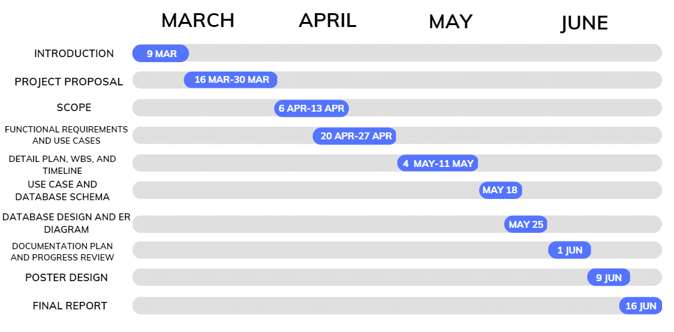

Gantt Chart FYP 1

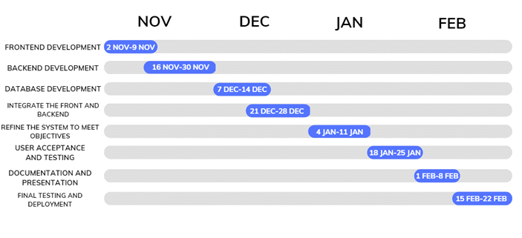

Gantt Chart FYP 2

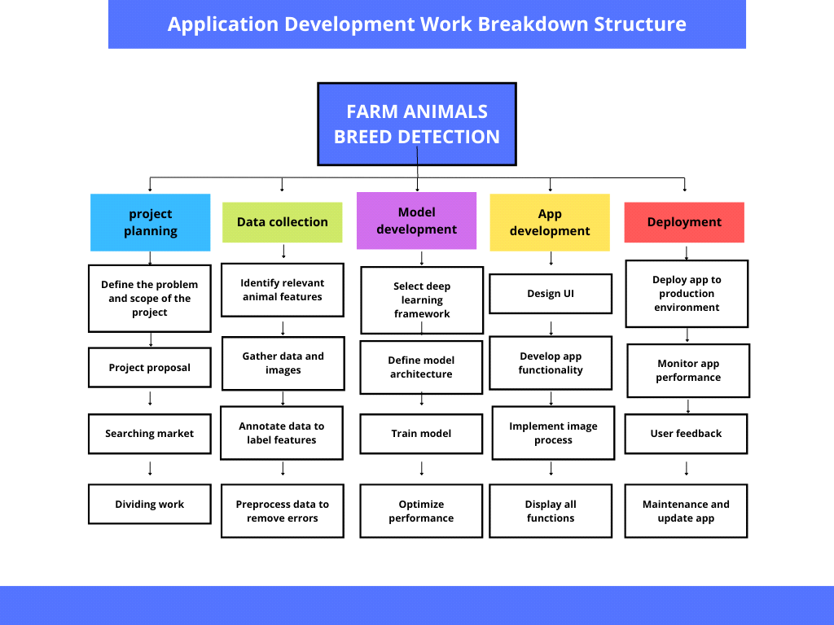

Work Breakdown Structure

## **FUNCTIONAL REQUIREMENTS:**

**Image Capture:**

* The system should allow users to capture images of farm animals using the mobile application.
* Users should be able to upload images from their device's gallery for breed detection.

**Breed Detection:**

* The system should accurately identify the breed of farm animals depicted in the images.
* Breed detection should support multiple species, including cows and goats, and distinguish between different breeds within each species.

**Gender Recognition:**

* The system should determine the gender of farm animals based on visual cues extracted from the images.
* Gender recognition should accurately classify animals as male or female.

**Weight Estimation:**

* The system should estimate the approximate weight of farm animals based on their size and morphology.
* Weight estimation algorithms should account for factors such as body proportions and posture in the image.

**Real-Time Processing:**

* The system should process image data in real-time to provide instant feedback to users.
* Processing times should be optimized to ensure minimal latency between image capture and result display.

## **NONFUNCTIONAL REQUIREMENTS:**

**Accuracy:**

* The system should achieve a high level of accuracy in breed detection, gender recognition, and weight estimation, with minimal false positives and negatives.

**Performance:**

* The system should be capable of processing images efficiently, even under varying lighting conditions and image quality.
* Response times for breed detection and other functionalities should meet acceptable performance standards.

**Scalability:**

* The system should be scalable to accommodate a growing number of users and images without compromising performance or accuracy.
* Backend infrastructure should be designed to handle increasing computational loads as the user base expands.

**User Interface:**

* The mobile application should have an intuitive and user-friendly interface, accessible to users with varying levels of technical proficiency.
* Navigation should be straightforward, and important features should be easily accessible.

**Security:**

* The system should prioritize the privacy and security of user data, implementing measures to protect sensitive information.
* Data transmission and storage should adhere to industry-standard security protocols to prevent unauthorized access or breaches.

**Reliability:**

* The system should be reliable and robust, capable of functioning consistently under normal operating conditions.
* Measures should be in place to handle errors gracefully and recover from system failures without data loss or corruption.

**Compatibility:**

* The mobile application should be compatible with a wide range of devices and operating systems, ensuring accessibility to a broad user base.
* Compatibility testing should be conducted to verify seamless operation across different platforms and device configurations.

## **HARDWARE REQUIREMENTS:**

To ensure optimal performance and functionality of the "Farm Animal Breed Detection" mobile application, the following hardware specifications are required:

**Camera:**

* The mobile device must be equipped with a built-in camera capable of capturing high-quality images.
* The camera should support autofocus and have adequate resolution for clear and detailed image capture.
* A rear-facing camera is recommended for capturing images of farm animals in real-world environments.

**RAM (Random Access Memory):**

* The mobile device must have a minimum of 2 GB RAM to support efficient operation of the application.
* Sufficient RAM is essential for smooth image processing, breed detection, and other computational tasks performed by the application.

**Storage Space:**

* The mobile device must have a minimum of 1 GB of free storage space to accommodate the installation of the application and store captured images and related data.
* Adequate storage space is necessary for storing app resources, user preferences, and temporary files generated during image processing.

## **HARDWARE COMPATIBILTY:**

The "Farm Animal Breed Detection" system is designed to be compatible with a variety of mobile devices, ensuring accessibility and usability for a broad user base. Specifically, the mobile application is compatible with devices running Android version 7 (Nougat) or higher. This compatibility requirement ensures that the application can leverage the latest features and optimizations available in newer Android versions while maintaining support for older devices.

By targeting Android version 7 and above, the system can cater to a significant portion of the mobile device market, encompassing a wide range of smartphones and tablets. Users with devices meeting this compatibility criterion can confidently install and utilize the "Farm Animal Breed Detection" application to capture images of farm animals, perform breed detection, gender recognition, and weight estimation tasks seamlessly.

Moreover, adherence to Android version 7 as the minimum requirement allows for efficient utilization of hardware resources and provides a consistent user experience across supported devices. It also ensures that the application can leverage advancements in mobile hardware capabilities, such as improved camera sensors and processing power, to enhance the performance and accuracy of farm animal identification tasks.

## **SUMMARY:**

The "Farm Animal Breed Detection" project encompasses a comprehensive set of functional and non-functional requirements, along with specific hardware specifications and compatibility considerations, aimed at delivering a robust and user-friendly mobile application for livestock management.

Functional requirements dictate the core functionalities of the application, including image capture, breed detection, gender recognition, and weight estimation, all of which must be executed accurately and efficiently in real-time.

Non-functional requirements ensure that the application meets performance, usability, security, and reliability standards, guaranteeing a seamless user experience and safeguarding user data.

Hardware requirements specify the minimum device specifications necessary for optimal application performance, including a camera, RAM, and storage space.

Compatibility considerations ensure that the application is accessible to a wide range of users, with support for Android devices running version 7 (Nougat) or higher, enabling widespread adoption and usability.

By adhering to these requirements and considerations, the "Farm Animal Breed Detection" application aims to revolutionize livestock management practices, providing farmers with valuable insights and tools for improved breed identification and management.

# **CHAPTER NO:4**

## **INTRODUCTION:**

This chapter offers an insightful exploration into the practical applications and technical intricacies of the "Farm Animal Breed Detection" system, presenting a detailed overview through the lens of use cases and sequence diagrams. Through meticulously crafted use case scenarios, readers gain a nuanced understanding of how the system is employed to address specific farm animal management tasks, from breed identification to health monitoring. Furthermore, the inclusion of sequence diagrams provides a visual representation of the intricate interactions between system components, elucidating the underlying processes and message exchanges that drive the system's functionality. By delving into these real-world scenarios and system interactions, this chapter offers readers a comprehensive understanding of the system's capabilities and implications in enhancing livestock management practices.

## **SEQUENCE DIAGRAM:**

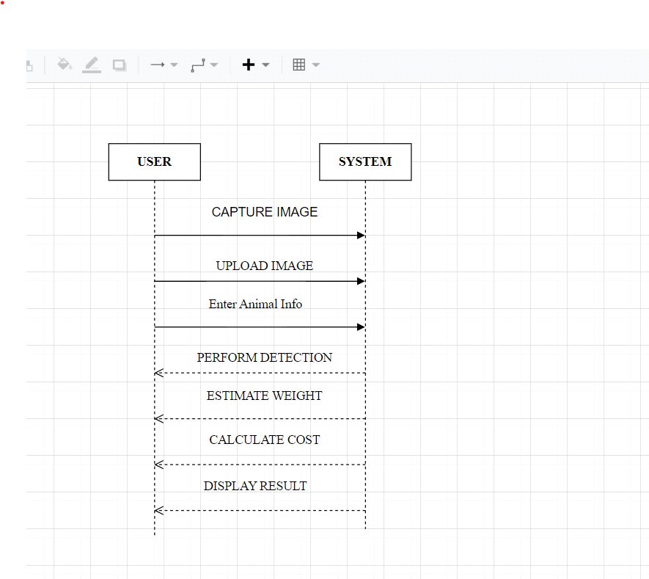

## **USE CASES**

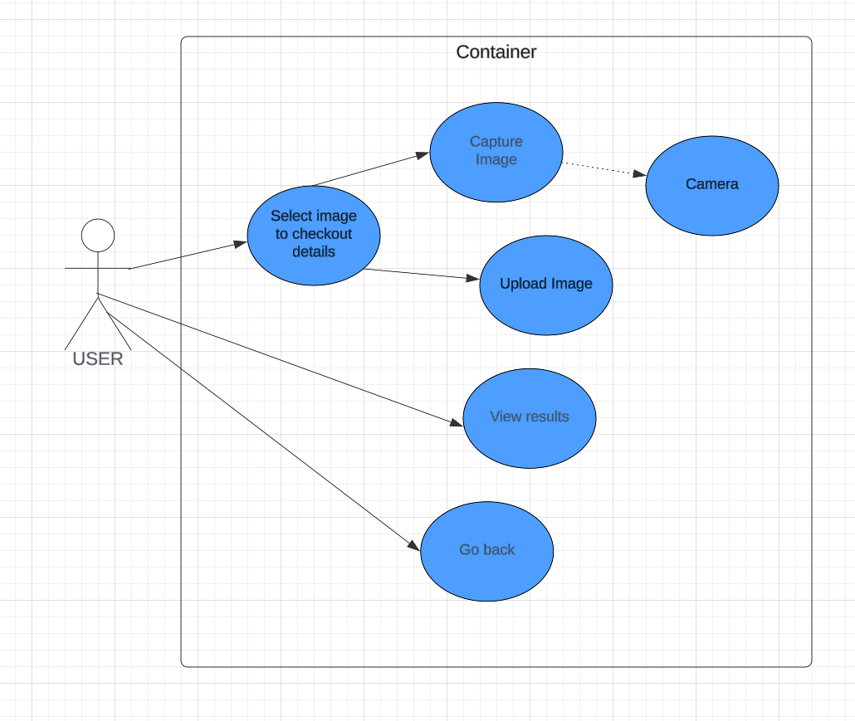

**SELECT IMAGE:**

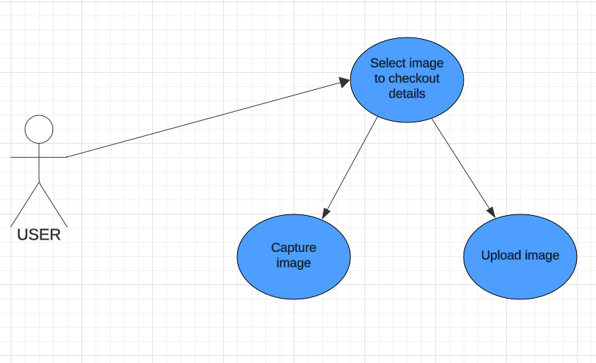

|  |  |  |
| --- | --- | --- |
| **Use Case Name:** | Select image | |
| **ID:** | 01 | |
| **Priority:** | High | |
| **Actors Involved:** | User | |
| **Brief Description:** | This option allow user to upload image or capture image from the camera. | |
| **Pre- Condition:** |  | |
| **Post- Condition:** |  | |
| **Normal Flow of Events:** | **Actor Actions:** i  Actor can upload or capture image from camera | **System Response:**  System check the given image and start generating results. |

**CAPTURE IMAGE:**

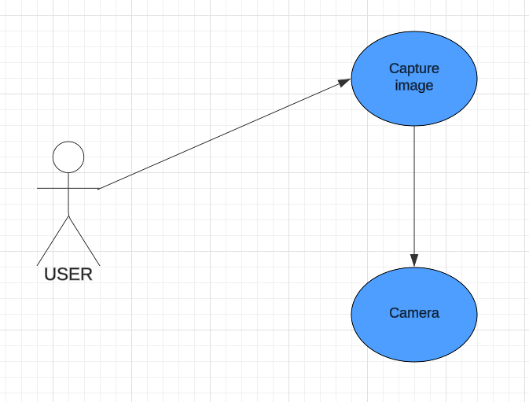

|  |  |  |
| --- | --- | --- |
| **Use Case Name:** | Capture image | |
| **ID:** | 02 | |
| **Priority:** | High | |
| **Actors Involved:** | User | |
| **Brief Description:** | This option opens the camera to capture the image. | |
| **Pre- Condition:** |  | |
| **Post- Condition:** |  | |
| **Normal Flow of Events:** | **Actor Actions:** i  User can capture image with the help of camera. | **System Response:**  System check the given image and start generating results. |

**VIEW RESULTS:**

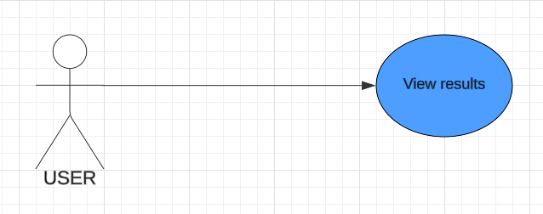

|  |  |  |
| --- | --- | --- |
| **Use Case Name:** | View results | |
| **ID:** | 03 | |
| **Priority:** | High | |
| **Actors Involved:** | User | |
| **Brief Description:** | After upload the image system generate the results and show it on the screen. | |
| **Pre- Condition:** |  | |
| **Post- Condition:** |  | |
| **Normal Flow of Events:** | **Actor Actions:** i  Upload the image and wait. | **System Response:**  System calculates the result and display it on the screen. |

**GO BACK:**

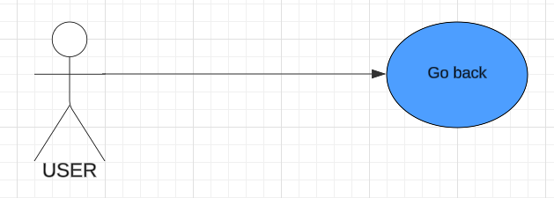

|  |  |  |
| --- | --- | --- |
| **Use Case Name:** | Go back | |
| **ID:** | 04 | |
| **Priority:** | High | |
| **Actors Involved:** | User | |
| **Brief Description:** | This option allow user to go back on the upload image page after viewing results. | |
| **Pre- Condition:** |  | |
| **Post- Condition:** |  | |
| **Normal Flow of Events:** | **Actor Actions:** i  User can go back after viewing results. | **System Response:**  System will take user to the main page. |

## **SUMMARY:**

This chapter provides a concise overview of the "Farm Animal Breed Detection" system, focusing on its practical applications and technical workings. Through use case scenarios, readers gain insight into how the system is utilized in farm animal management tasks, while sequence diagrams offer a visual representation of system interactions. By examining real-world scenarios and internal processes, readers develop a clear understanding of the system's capabilities and its potential to enhance livestock management practices.

# **CHAPTER NO:5**

## **Introduction:**

In this chapter, we have discussed about the test cases to determine whether the software is working the way it should and producing the expected results. We also test cases and usability test cases to test our software. This will help the readers to know about all the minor as well as the major working options of the software. After the completion of the implementation phase testing plays a vital role for making sure that the system works properly. Once the software was developed the testing phase started. Each and every screen and button were tested according to the requirements and functionalities. Even though the application is complex it does use I treated functionality as one window is being used multiple times for different kinds of functionalities.

## **Test Cases:**

**TEST CASE 1:**

|  |  |  |  |
| --- | --- | --- | --- |
| **Requirement Reference** | 1 | **Project Name** | Farm Animal Breed Detection. |
| **Test Case Id** | 1.1 | **Test Type** | Functionality |
| **Test Case Description** | To test that the button of select to check out details are working. | | |
| **Test Steps** | Shows both pick from Gallery and Take a picture option. | | |
| **Expected Result** | Shows both Pick from Gallery and Take a picture option. | | |
| **Actual Result** | Shows both options. | | |
| **Pass/Fail** | Pass | | |
| **Date Prepared** | March 15, 2024 | | |
| **Date Run** | March 22, 2024 | | |
| **Prepared By** | Syed Kaif Ali, Shah Abdul Munim | | |
| **Tested By** | Hamid Ghulam Hamza | | |

**TEST CASE 2:**

|  |  |  |  |
| --- | --- | --- | --- |
| **Requirement Reference** | 1 | **Project Name** | Farm Animal Breed Detection. |
| **Test Case Id** | 1.2 | **Test Type** | Functionality |
| **Test Case Description** | Check If Pick from Gallery is working. | | |
| **Test Steps** | Click on Pick from Gallery. | | |
| **Expected Result** | Open Gallery to select image. | | |
| **Actual Result** | Gallery opened to select image. | | |
| **Pass/Fail** | Pass | | |
| **Date Prepared** | March 15, 2024 | | |
| **Date Run** | March 22, 2024 | | |
| **Prepared By** | Syed Kaif Ali, Shah Abdul Munim | | |
| **Tested By** | Hamid Ghulam Hamza | | |

**TEST CASE 3:**

|  |  |  |  |
| --- | --- | --- | --- |
| **Requirement Reference** | 1 | **Project Name** | Farm Animal Breed Detection. |
| **Test Case Id** | 1.3 | **Test Type** | Functionality |
| **Test Case Description** | Check If Take a Picture Option is working. | | |
| **Test Steps** | Click on Take a picture and capture image. | | |
| **Expected Result** | Open camera and capture an image. | | |
| **Actual Result** | Camera opened and can capture image. | | |
| **Pass/Fail** | Pass | | |
| **Date Prepared** | March 15, 2024 | | |
| **Date Run** | March 22, 2024 | | |
| **Prepared By** | Syed Kaif Ali, Shah Abdul Munim | | |
| **Tested By** | Hamid Ghulam Hamza | | |

**TEST CASE 4:**

|  |  |  |  |
| --- | --- | --- | --- |
| **Requirement Reference** | 1 | **Project Name** | Farm Animal Breed Detection. |
| **Test Case Id** | 1.4 | **Test Type** | Functionality |
| **Test Case Description** | User can view Details of the selected Image. | | |
| **Test Steps** | Select an image from gallery or capture from camera and click on Find out Details button. | | |
| **Expected Result** | User can Find out details of the selected picture. | | |
| **Actual Result** | User view the Details of the image. | | |
| **Pass/Fail** | Pass | | |
| **Date Prepared** | March 15, 2024 | | |
| **Date Run** | March 22, 2024 | | |
| **Prepared By** | Syed Kaif Ali, Shah Abdul Munim | | |
| **Tested By** | Hamid Ghulam Hamza | | |

**TEST CASE 5:**

|  |  |  |  |
| --- | --- | --- | --- |
| **Requirement Reference** | 1 | **Project Name** | Farm Animal Breed Detection. |
| **Test Case Id** | 1.5 | **Test Type** | Functionality |
| **Test Case Description** | The Application must show an error with invalid image message for either selecting image from gallery or capture image using camera. | | |
| **Test Steps** | 1. Select an invalid image from gallery. 2. Capture image by using the camera. | | |
| **Expected Result** | Get error with message to choose a valid image. | | |
| **Actual Result** | Shows the error with message of selecting valid image. | | |
| **Pass/Fail** | Pass | | |
| **Date Prepared** | March 15, 2024 | | |
| **Date Run** | March 22, 2024 | | |
| **Prepared By** | Syed Kaif Ali, Shah Abdul Munim | | |
| **Tested By** | Hamid Ghulam Hamza | | |

## **Summary:**

We test our software to get our expected results of our software or whether a system under test satisfies requirements or works correctly. After test cases, we get satisfied results the usability test case.

# **CHAPTER NO:6**

## **INTRODUCTION:**

In this chapter, we embark on a visual journey through the "Farm Animal Breed Detection" mobile application, exploring its interface, functionalities, and user experience through a series of screenshots. As technology continues to revolutionize agricultural practices, the "Farm Animal Breed Detection" app stands at the forefront, offering farmers and livestock managers a powerful tool for breed identification, gender recognition, and weight estimation. Through these screenshots, readers will gain firsthand insight into the intuitive design, seamless navigation, and practical utility of the application, illuminating its role in modernizing farm animal management practices and empowering users with actionable insights. Join us as we navigate through the interface and functionalities of the "Farm Animal Breed Detection" app, unveiling its potential to revolutionize the way we interact with and manage farm animals.

## **SCREENSHOTS:**

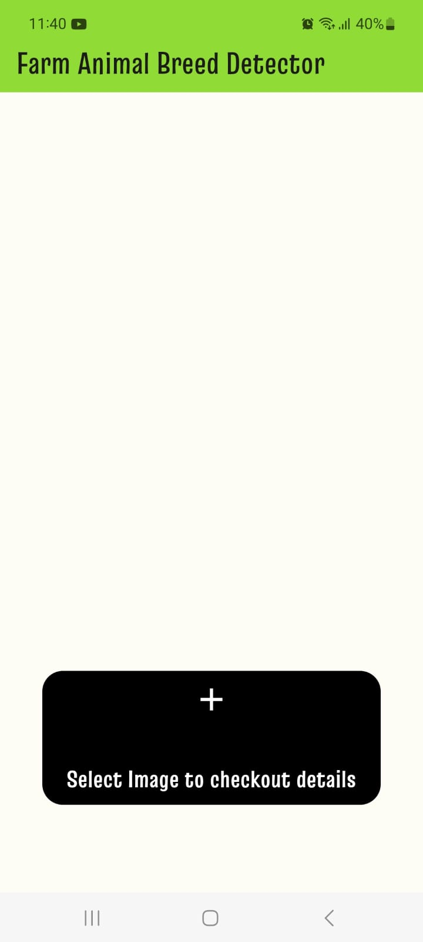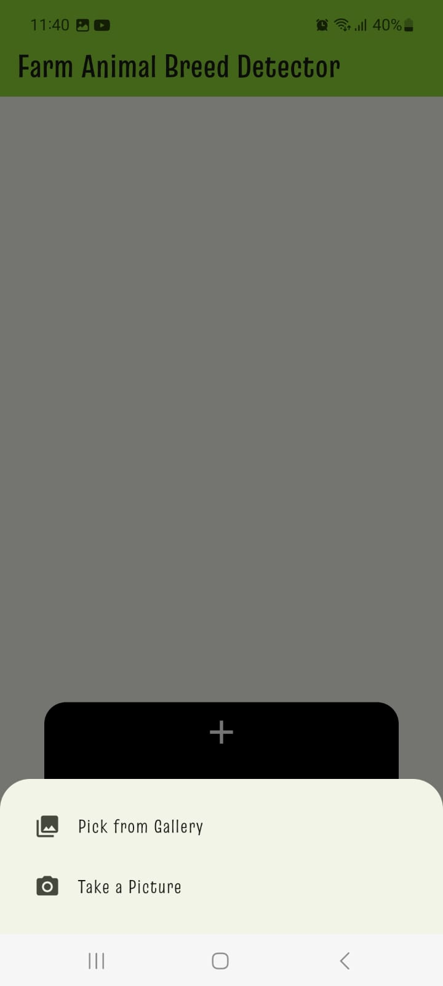

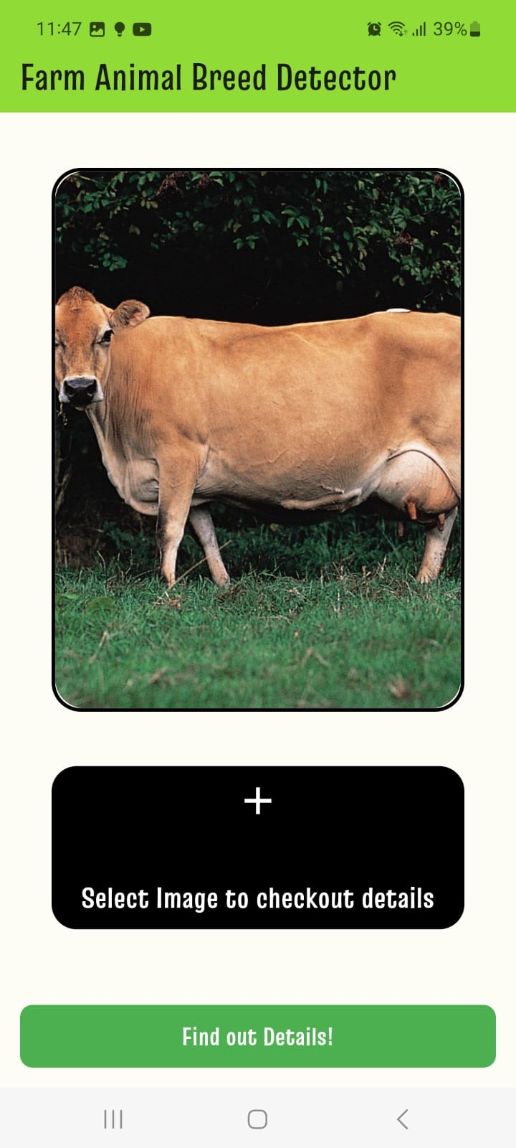

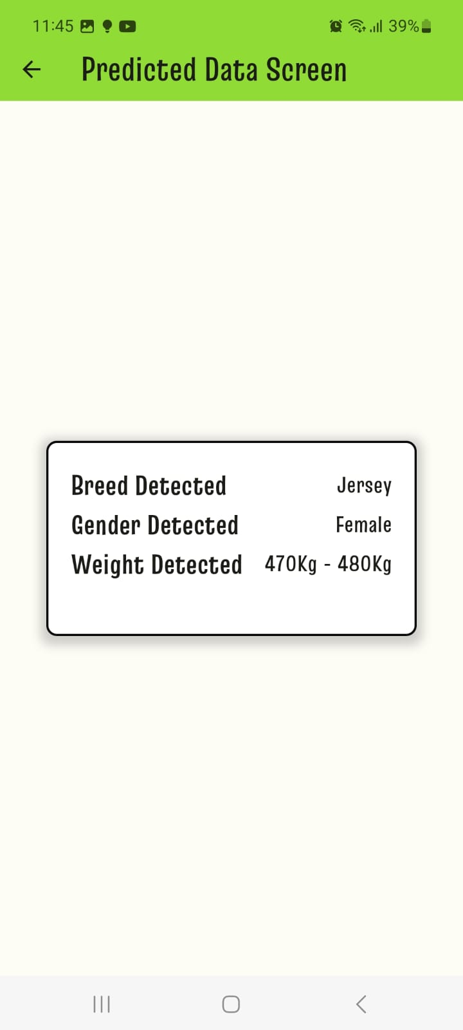

## **SUMMARY:**

This chapter provides a visual exploration of the "Farm Animal Breed Detection" mobile application, showcasing its interface, features, and user experience through a series of screenshots. As technology continues to shape agricultural practices, the application emerges as a pivotal tool for farmers and livestock managers, offering breed identification, gender recognition, and weight estimation functionalities. Through these screenshots, readers gain firsthand insight into the application's intuitive design, seamless navigation, and practical utility, underscoring its potential to modernize farm animal management practices. By unveiling the interface and functionalities of the "Farm Animal Breed Detection" app, this chapter highlights its transformative impact on livestock management and empowers users with actionable insights for informed decision-making.

# **CHAPTER NO:7**

## **INTRODUCTION:**

In this final chapter, we confront the limitations and challenges inherent in the development and implementation of the "Farm Animal Breed Detection" system. While the system represents a significant advancement in livestock management, it is essential to acknowledge the constraints and hurdles encountered throughout the project lifecycle. By candidly examining these limitations and challenges, we gain valuable insights into areas for improvement, potential risks, and avenues for future research and innovation. Through a thorough exploration of these aspects, we aim to provide a holistic understanding of the complexities and considerations involved in leveraging technology for farm animal management.

## **LIMITATIONS AND CHALLENGES:**

**Limitations:**

Data Availability:

* One of the primary limitations faced during the project was the availability of diverse and representative datasets for training the breed detection and recognition models.
* Limited access to annotated images of farm animals, especially across different breeds and genders, posed challenges in achieving optimal model performance and generalization.

Algorithm Accuracy:

* Despite efforts to optimize the breed detection, gender recognition, and weight estimation algorithms, limitations in algorithm accuracy persisted.
* Variability in animal poses, lighting conditions, and image quality posed challenges in accurately identifying breeds and other attributes, leading to occasional misclassifications.

Computational Resources:

* The computational resources required for training and deploying machine learning models for breed detection and other tasks were significant.
* Limited access to high-performance computing resources and cloud infrastructure constrained the scalability and efficiency of model training and inference processes.

**Challenges:**

Real-World Deployment:

* Deploying the "Farm Animal Breed Detection" system in real-world farm environments presented logistical challenges, including variability in lighting conditions, environmental factors, and device compatibility.
* Ensuring consistent performance and reliability across diverse settings proved to be a significant challenge.

User Adoption:

* Encouraging user adoption and acceptance of the mobile application among farmers and livestock managers posed challenges.
* Overcoming barriers related to technological literacy, resistance to change, and cultural factors required targeted outreach, education, and user engagement strategies.

Regulatory Compliance:

* Compliance with regulatory requirements and data privacy regulations presented challenges, particularly concerning the collection, storage, and processing of sensitive information such as animal health data.
* Adhering to legal and ethical standards while ensuring the functionality and utility of the system required careful consideration and planning.

## **SUMMARY:**

In this chapter, we have critically examined the limitations and challenges encountered during the development and implementation of the "Farm Animal Breed Detection" system. From constraints related to data availability and algorithm accuracy to challenges associated with real-world deployment, user adoption, and regulatory compliance, each aspect presents unique hurdles to overcome. By acknowledging these limitations and challenges, we gain valuable insights into areas for improvement and opportunities for future research and innovation in the field of farm animal management. Despite these challenges, the "Farm Animal Breed Detection" system represents a significant step forward in leveraging technology to empower farmers and livestock managers with actionable insights for improved decision-making and livestock management practices.